Add line win event
- Select slotcontroller, select pay line, check showevent, click ”+”
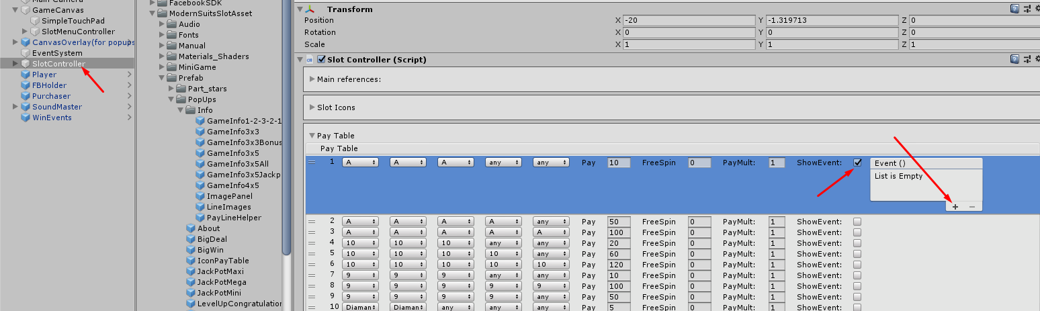
- Drag WinEvents object in to empty field
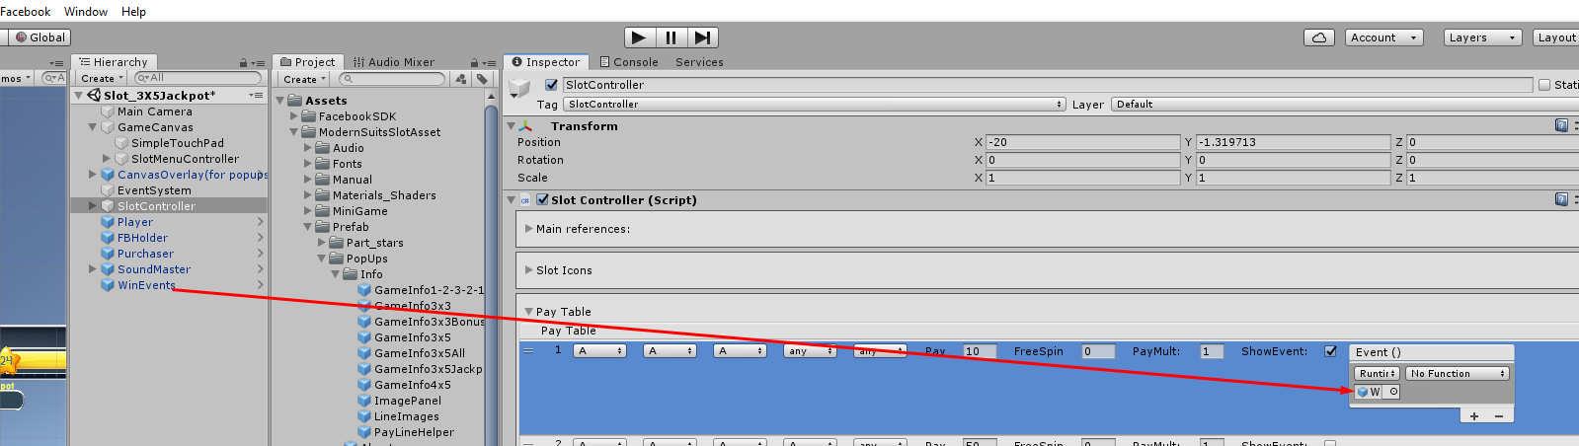

- Add your EventHandler method to SlotEvents.cs
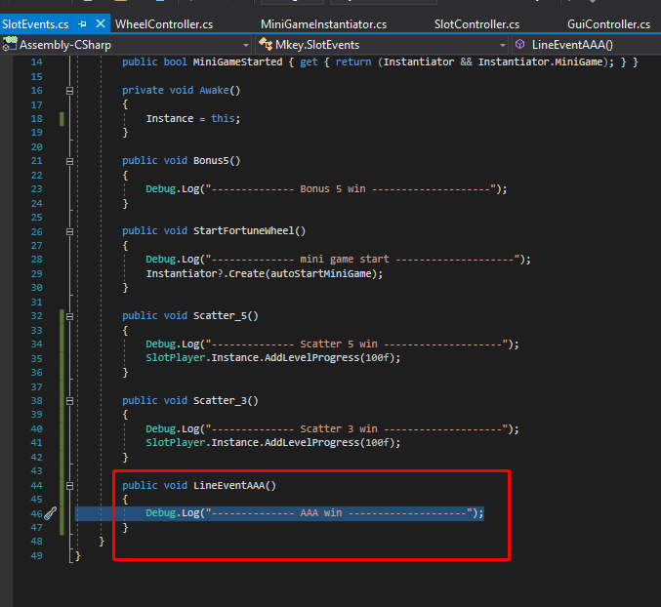
- Select your handler
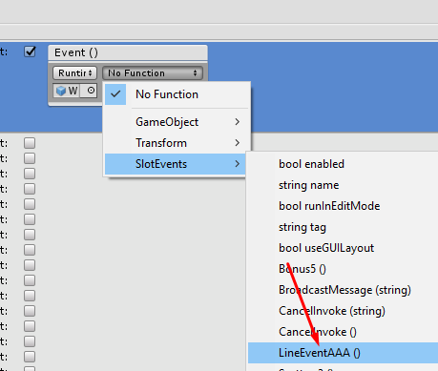
- Uncheck ShowEvent (this does not affect the triggering event)
